To Install Python 3.11: -
- Firstly clone https://github.com/JetsonHacksNano/build_python.git repository to jetson nano.
- Then, go into that folder using cd command and then bash using
$ bash ./build_python3.sh
- Build took almost 2 hours to complete.
- Next step, write following commands
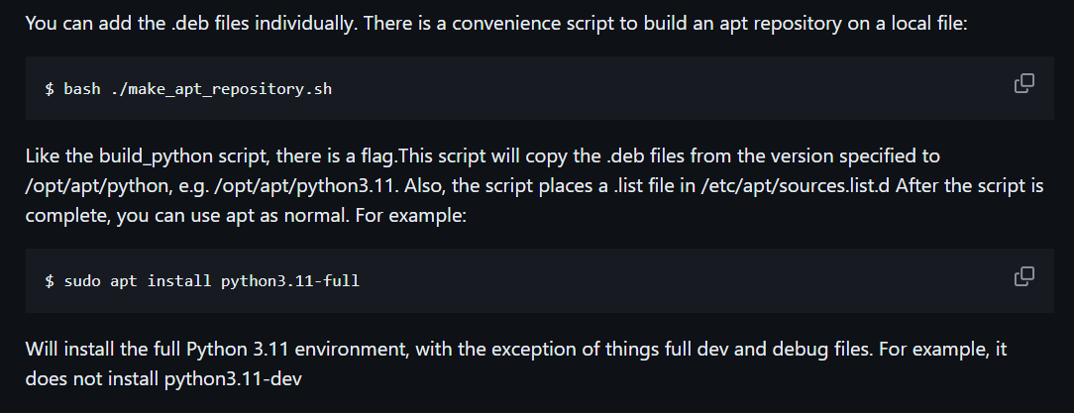
- Now, let’s install pip: - python3.11 -m ensurepip –upgrade.
- Make a new project directory named elc using mkdir elc, switch over to that directory using cd elc.
- Make a virtual environment named venv using command: -python3.11 -m venv .venv
- To activate virtual environment.
Command: - source .venv/bin/activate
- To deactivate environment, use command: - deactivate.
Refer this YouTube video for any other help: -https://www.youtube.com/watch?v=LSdXakt8nZ8
To install Jupyter Notebook: -
- To install jupyter notebook: - pip3 install jupyter.
- To run Jupyter notebook, write a command: - jupyter notebook.
To run Code on our Jetson Nano: -
- Open the terminal on Jetson Nano.
- Go into elc directory using cd elc.
- Activate the virtual environment using: - source .venv/bin/activate
- Write jupyter notebook command for running Jupyter notebook.

